## Commands Utilities

This assignment expects the participant to identify specific command(s) OR perform the given action using one or commands as per the given question. You are requested to maintain the answers (i.e command(s) as per given question) for all questions below.

**Mandatory Questions**

1. Which command is used to know the current working directory?

Ans.



1. How would you find out its contents?

Ans. 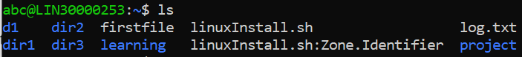

1. Identify the commands with inputs to do the following
   1. create a directory d1 –



* 1. create a subdirectory d2 in d1



* 1. change to directory d2

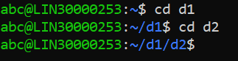

* 1. create an empty file “f1.txt”



* 1. display the contents of “f1.txt”



* 1. view the contents of d1 from current directory d2



1. Use the ls command with its options. How will you identify directories from the listing?

Ans. 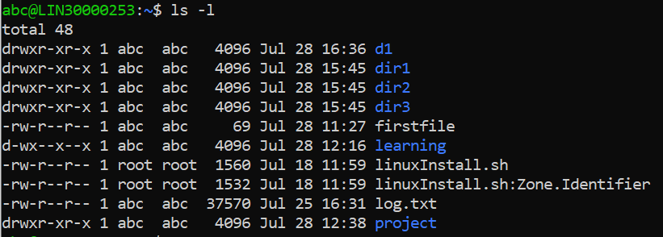

1. Use ls to do the following
   1. List files with single character names.

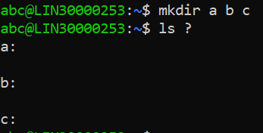

* 1. List hidden files also. [ Note : Hidden files are files having name started with a “.” ]



* 1. Suppose there are files tb1.1, tb2.1, tb3.1, ….tb10.1. Write command to list all the files [Hint: use wild card characters]

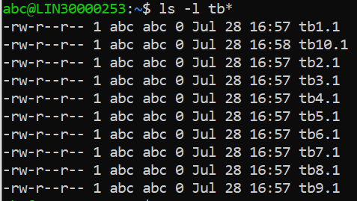

1. Write the command to list all files in descending order of their size.

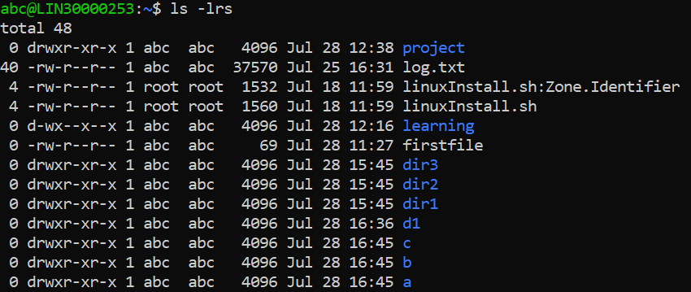

1. Suppose there are files temp1, temp2, temp3. Write command to remove the files without listing them explicitly

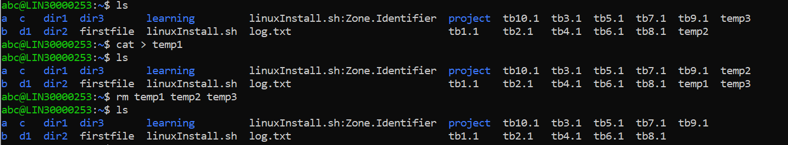

1. Which command is used to list top few lines in the file?

Ans. Head Filename

1. Create a directory “testdir”



1. Use cp command to do the following
   1. Copy the file tb1.1 (created above) in the same directory.



* 1. Write a command to copy all the files i.e tb1.1,tb2.1,tb3.1,…..tb10.1 in a new directory –“new”



* 1. Create a subdirectory in new in named“new1”.



* 1. Write a command to copy selectively only tb2.1, tb6.1, tb7.1 and tb10.1 in the directory new1.

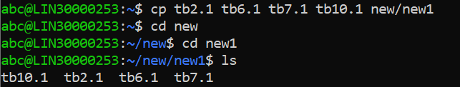

* 1. Write a command to copy the entire directory “new” to a directory “newprogs”. [Note : use the –R option of “cp” command ]

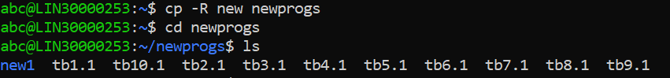

1. Find out the difference between
   1. “mv” & “cp”

cp command will Copy the files

mv command will Move the files

* 1. “rm”, “rmdir”

rm removes the directories along with subdirectories and files

rmdir removes the directories

* 1. “mkdir” and “mkdir -p”

mkdir will create new directories

mkdir -p it will create parent directories if needed and even if they exist already it won’t give any errors

1. Use a single command rmdir once to remove “testdir” and all its sub directories and files created above.



1. Which command is used to get the manual information of a command?

Ans. man

1. If you are not able to change to a directory what could be the likely cause?

Ans. We might not have the permission for the same. Denied Access for the given directory

1. Explain the differences among the following commands:  
                 a. cd /

Change the directory to the Root Directory

  b. cd ..

Change the directory to the Parent Directory

  c. cd

Change the directory to the Home Directory

  d. cd ../..

Change the Present Directory to Another Directory

**Advanced Optional Questions**

1. How could you display the inode number of a file?

Ans. An inode is a file data structure that store information about any Linux file except its name and data

Eg:- ls -i

1. What is the pipe symbol? What effect does it have?

Ans. Pipe Symbol will display the output page wise so that it can be read easily

1. Find out the details of “ps” command ?

Ans. ps command stands for Process Status Command. The ps command is used to list the active processes, their PIDs, and other data depending on the arguments used.